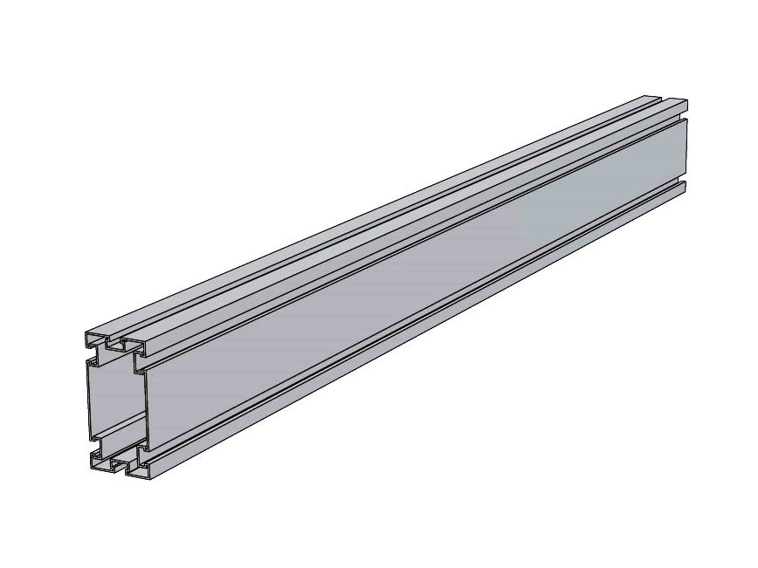ISA’s Main 6x3 Strut Rail is typically used as the main supporting rail for the 3x2 module rails. This rail is a higher capacity main rail where the 4x3 rail capacity is exceeded. It is also used with the PSS as the sleeper, or load distribution rail, for the rafter style roof structures such as Apartments & Hotels.

Physical Characteristics:

Dimensions: 6” High x 3” Wide

Weight: 2.51 Lbs/Ft.

Structural Characteristics:

Syymin = 1.1.848 in3 Iyymin = 2.772 in4 ryymin = 1.14 in

Szzmin = 3.432 in3 Izzmin = 10.296 in4 rzzmin = 2.19 in

Ag = 2.149 in2 Ae = 2.149 in2

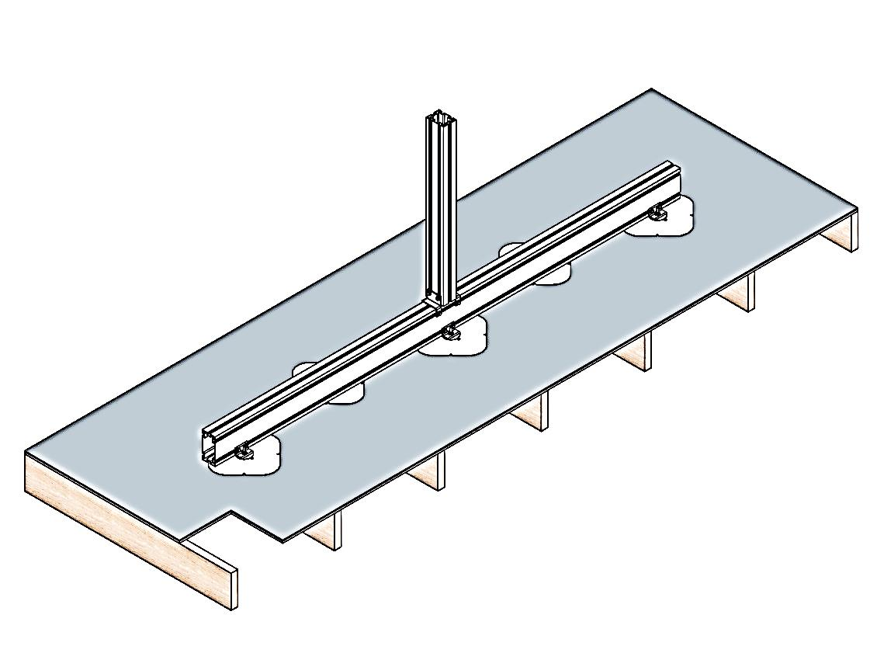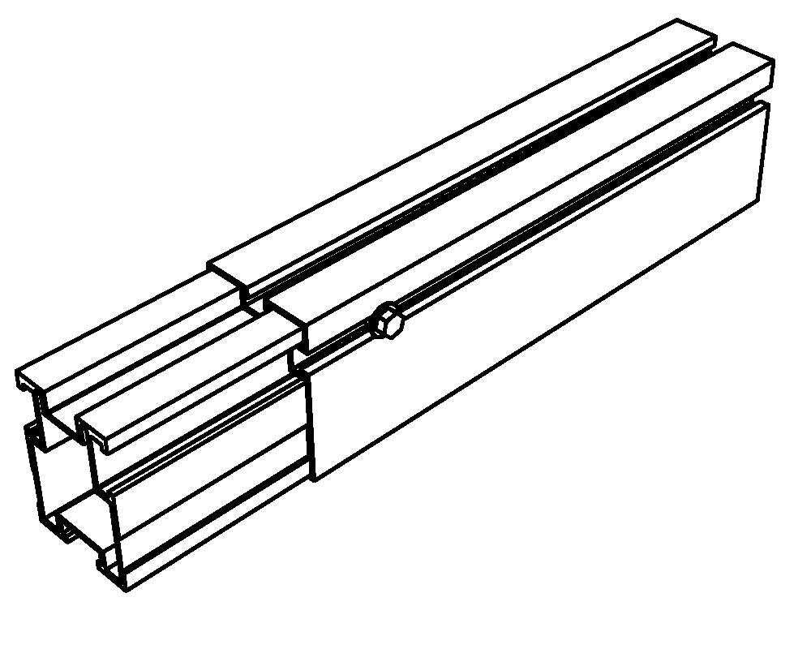Material:

-Extruded Aluminum, 6061-T6/6005-T6

Support Span Capacity:

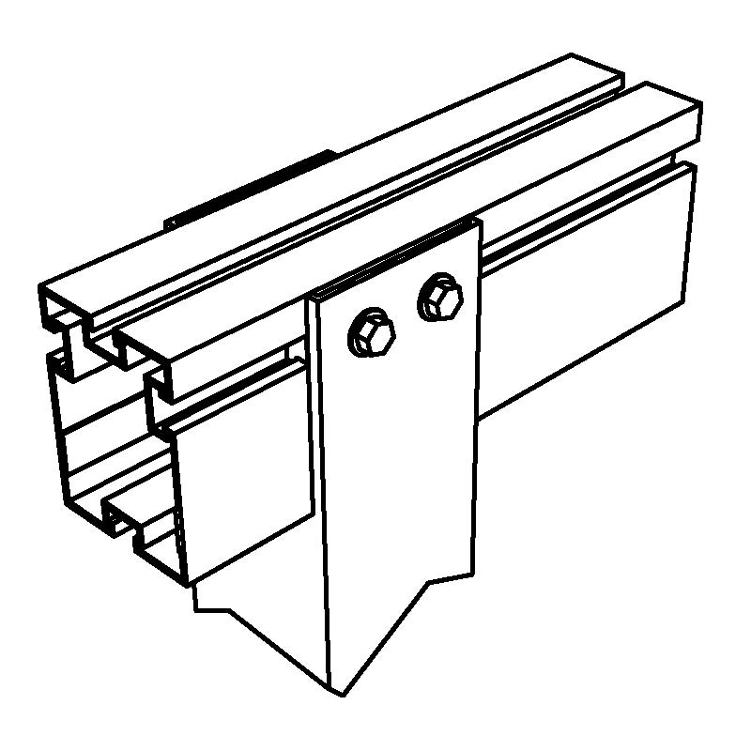24 Ft. – As module rail

Up to 15 Ft. – As Main Support Rail

Roof Attachment Methods:

Post with U Bracket

Post with Vertical Strut Member

Panel Rail Attachment:

Cleat Connection

Sleeper Application

Bracing Attachment:

Channel Bracket with Nut Bar

Channel Rail with Nut Bar

Warranty:

20 Years