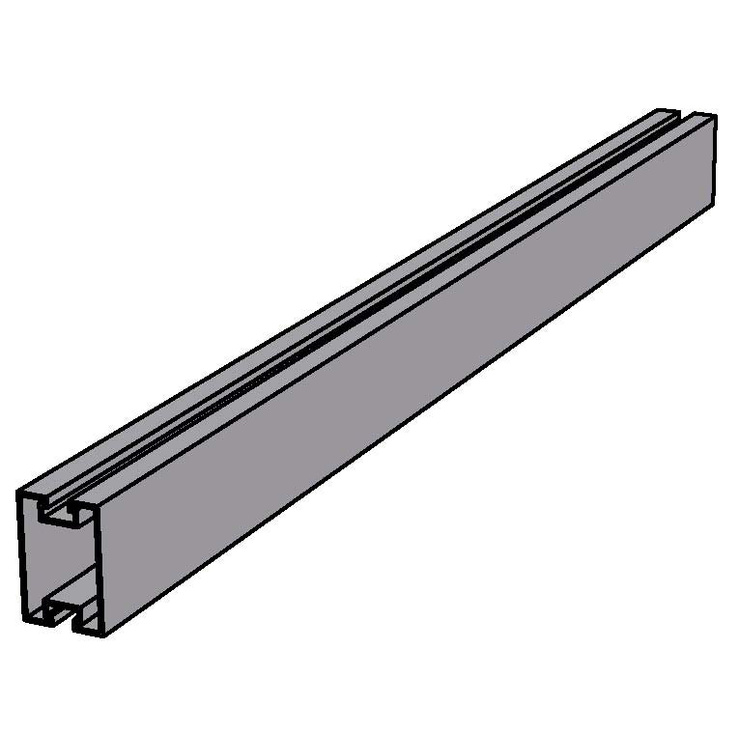The 3x2 Panel Rail is the standard rail used to support solar panels and has a span capacity of 12 feet. This rail is also used as the main bracing rail for the WSS Elevated Racking System. Panels clamp in place on rails with ISA’s 1/6 turn slot nuts.

Physical Characteristics:

Dimensions: 3” High x 2” Wide

Weight: 1.2 Lbs/Ft.

Structural Characteristics:

Syymin = 0.83 in3 Iyymin =0 .83 in4 ryymin = 0.90 in

Szzmin = 1.24 in3 Izzmin = 1.86 in4 rzzmin = 1.35 in

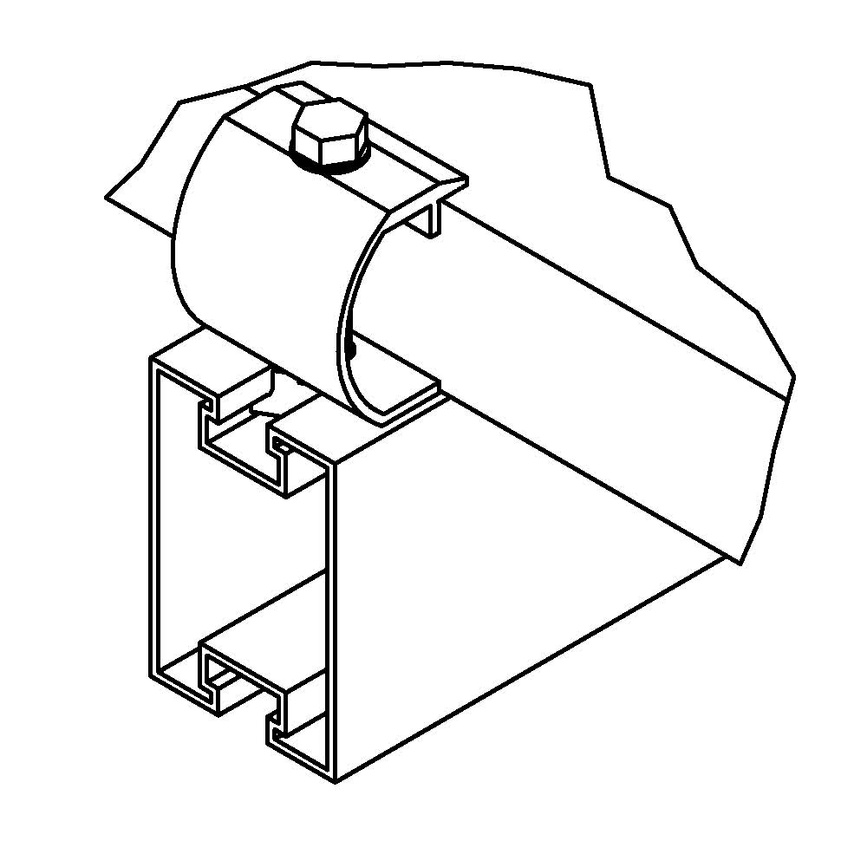Ag = 1.01 in2 Ae = 1.01 in2

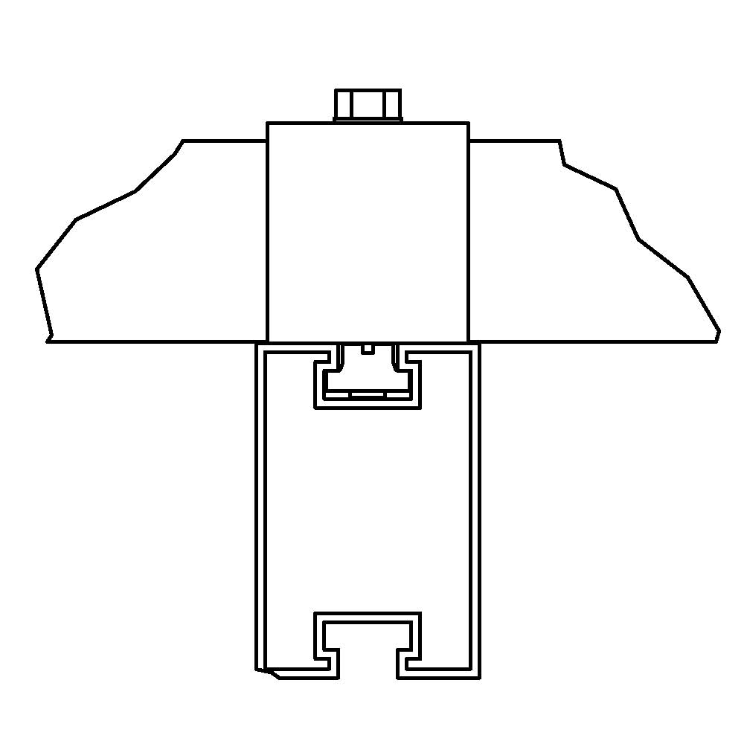

Material:

-Extruded Aluminum, 6061-T6/6005-T6

Support Span Capacity:

Up to 12 Ft. – Dependent on load conditions

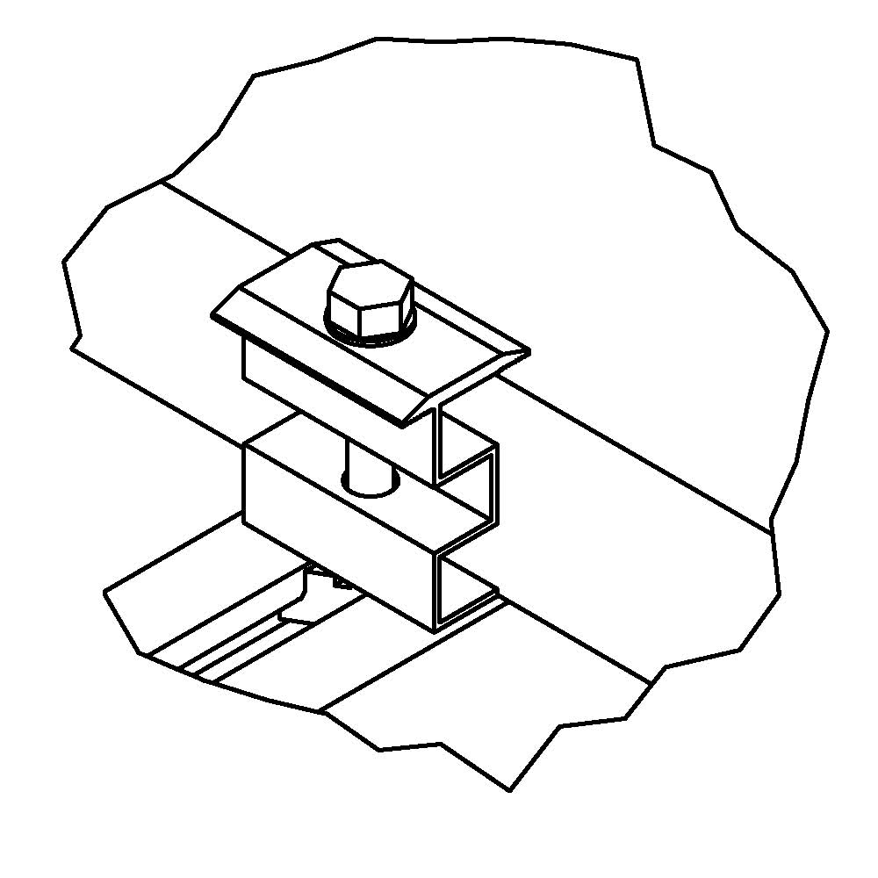

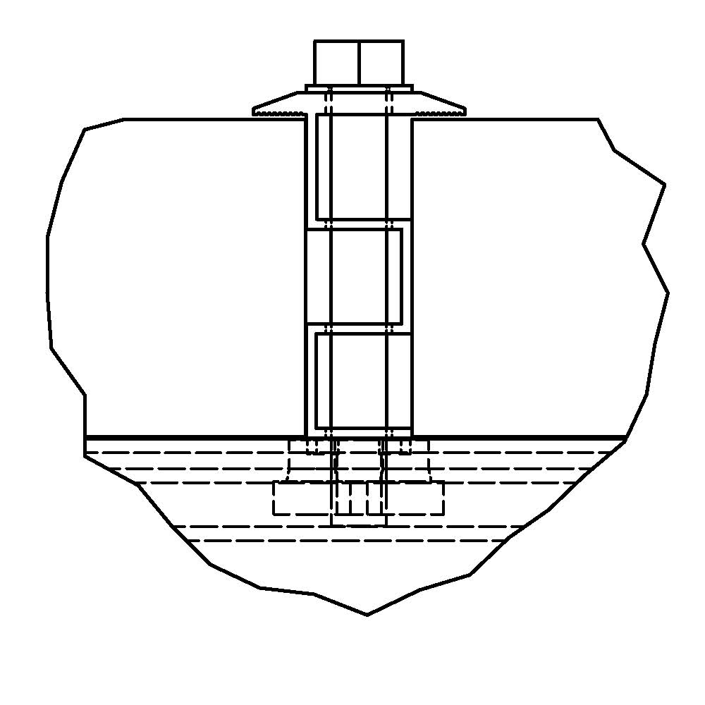Rail Attachment Method:

ISA T-Slot Cleat Bolted to Main Rail

Post with Vertical Strut Member

Panel Attachment Method:

ISA C-Clip (end)

ISA Waffle Clip (Inner)

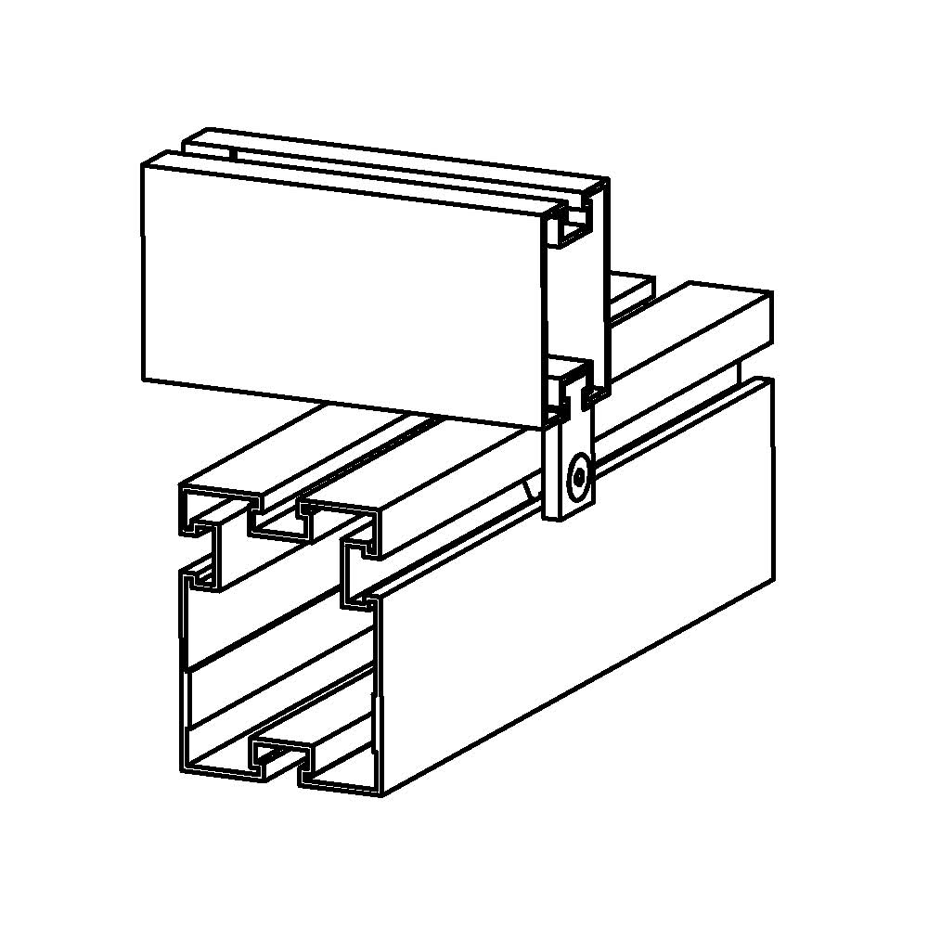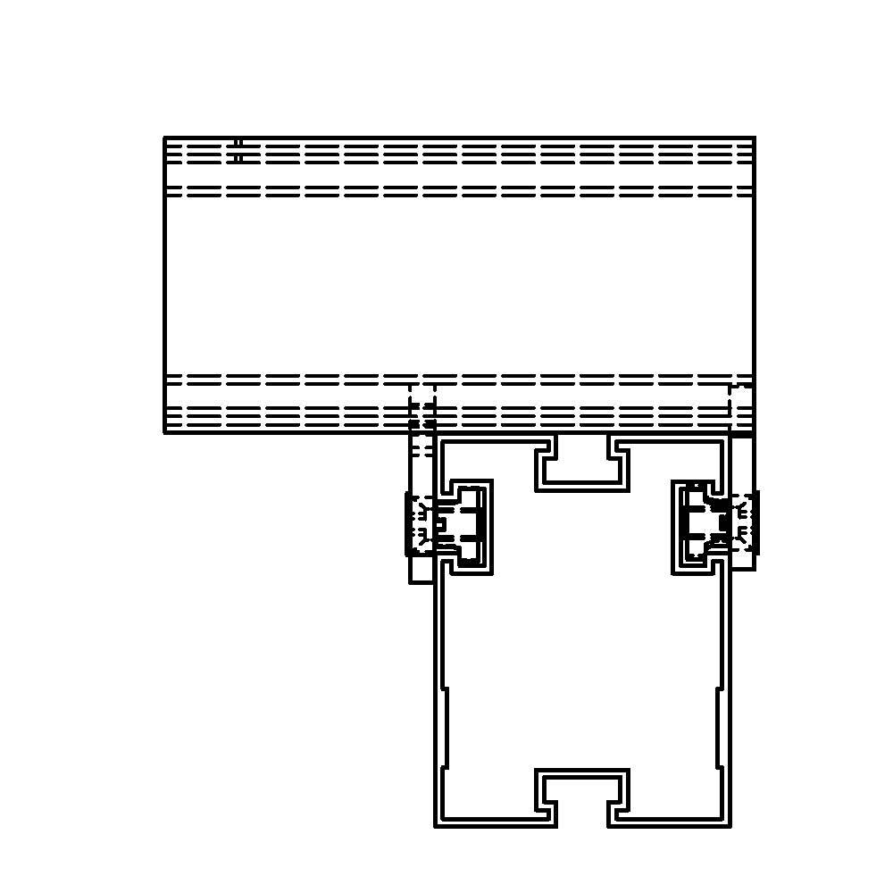

Bracing Attachment:

ISA Channel Bracket

ISA U-Channel

Warranty:

20 Years

